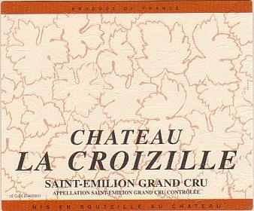

Chateau La Croizille
St. Emilion Grand Cru

Varietals: 70% Merlot, 30% Cabernet Sauvignon

Soil: Southernly-oriented slopes of the calcareous clay plateau of Saint-Emilion
Surface: 5 hectares, of which 1.5 ha is used for the first wine,
Château La Croizille
Average Production: 20hl/ha
Age of the vineyard: 35 years on average, with very old vines
Plant Density: 6,600 vines/hectare
Average production: 40 to 60 Hectolitres

Viticulture: Short pruning, green covering between the rows, defoliation, green harvest, hand-picking and hand sorting of the grapes.

Winemaking: Traditional winemaking after complete destemming, 3-5 weeks of maceration with temperature control by watering or heating.

Ageing: 18 months exclusively in new oak barrels (originating from the Allier, with average or medium toast)

Tasting Notes: This great wine which is almost as black as printer’s ink has an overwhelming nose of black fruit with a roasted touch. It is rich, complex and juicy and impresses with its harmony between a large but supple texture, fine tannins, and intense flavors.

Cellaring: 8 to 15 years

